Term 1
29 Jan – 13 Apr

Term 2
30 Apr – 6 July
Term 3
23 July – 28 September
Term 4
15 Oct – 20 Dec

18 May 2018
Early June 2018
Easter Camp
29 Mar – 1 Apr
19 - 27 May 2018
18 to 23 March
26 to 28 January
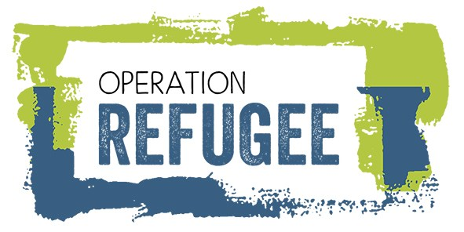
June 2018
January

YOUTH OF THE NATION
April
July

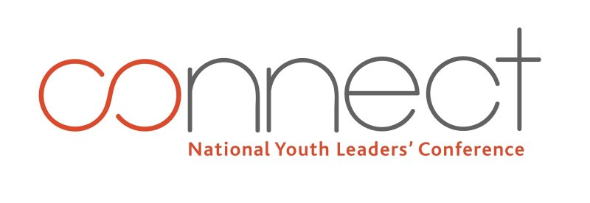

20-22 Julyr

Ear

Ear

